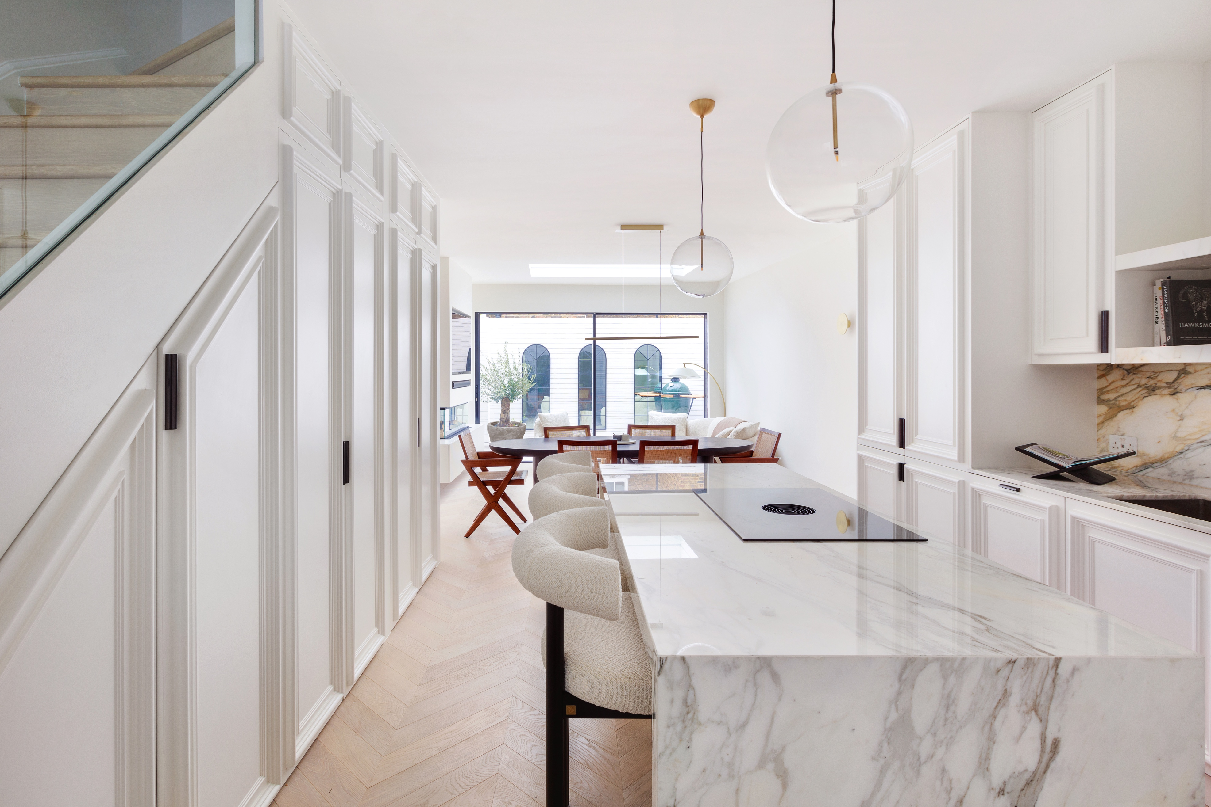
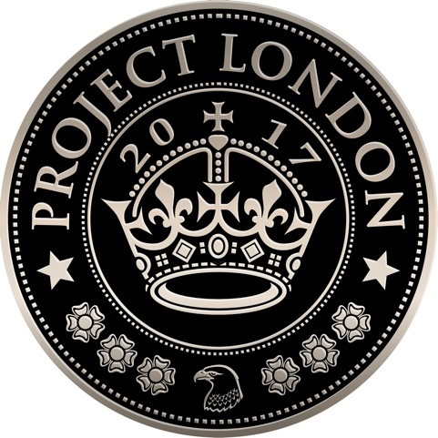

Architecture | Interior Design | Project Management

Interior Designer – Dubai
Project London – Dubai is seeking a Mid-weight / Senior Interior Designer to join us in the UAE.
We are an award-winning architecture, interior design, and project management studio specialising in high-end residential projects. Having built a strong reputation in London, we are now expanding into Dubai to replicate our successful model in a vibrant and fast-growing market.
This is a rare opportunity to play a pivotal role in launching our Dubai business, working closely with the director to establish our presence, develop an interiors portfolio, and help build a team from the ground up.

About You
You are an enthusiastic and ambitious interior designer with a passion for high-end residential work. You thrive on responsibility and are excited by the opportunity to contribute to the growth of a new studio in one of the most dynamic design markets in the world.
You balance creativity with strong organisational and commercial skills, capable of delivering exceptional work while maintaining clear communication with clients, suppliers, and colleagues.

Key Responsibilities
- Prepare client presentations and design packages tailored to luxury residential projects.
- Manage project timelines and budgets, ensuring efficiency and profitability.
- Source, research, and build relationships with leading suppliers in Dubai and internationally.
- Create detailed schedules and manage the coordination of procurement, delivery, and installation.
- Communicate confidently with clients, suppliers, consultants, and the design team.
- Support the director in pitching, onboarding, and delivering projects.
- Contribute to shaping systems, processes, and standards for the Dubai studio.
- Represent Project London professionally within the UAE design and property community.

Required Qualifications and Skills
- Degree in interior design or architecture.
- Minimum of 6 years’ post-degree professional experience, ideally in the high-end residential sector.
- Strong design portfolio demonstrating creativity and attention to detail.
- Proficiency in Vectorworks (2D), Adobe InDesign, and Microsoft Office preferred.
- Excellent organisational and communication skills with the ability to manage multiple projects.
- Fluent in written and spoken English, with strong presentation skills.
- Knowledge of UAE suppliers, procurement processes, and local regulations (or readiness to adapt quickly).
- Commercial awareness with an understanding of working to budgets and timelines.
- Entrepreneurial spirit, eager to help establish and grow a new venture.

Why Join Us?
- Be part of the founding team for Project London – Dubai, with direct impact on shaping the business.
- Work on high-end residential interiors for discerning clients in one of the world’s most exciting markets.
- Competitive tax-free salary based on experience.
- Opportunity for career progression as the studio grows, including future leadership potential.
- Join a dynamic, collaborative, and ambitious team with a proven track record in London.

How to Apply
Please send your CV, portfolio PDF, salary expectations, and availability to start to info@projectlondon.co.uk.

Additional Information
- Applications are open to candidates already based in the UAE
- You must hold the necessary documents entitling you to live and work in the UAE.
- We regret that we can only respond to successful candidates.
- No recruitment agency applications please.

