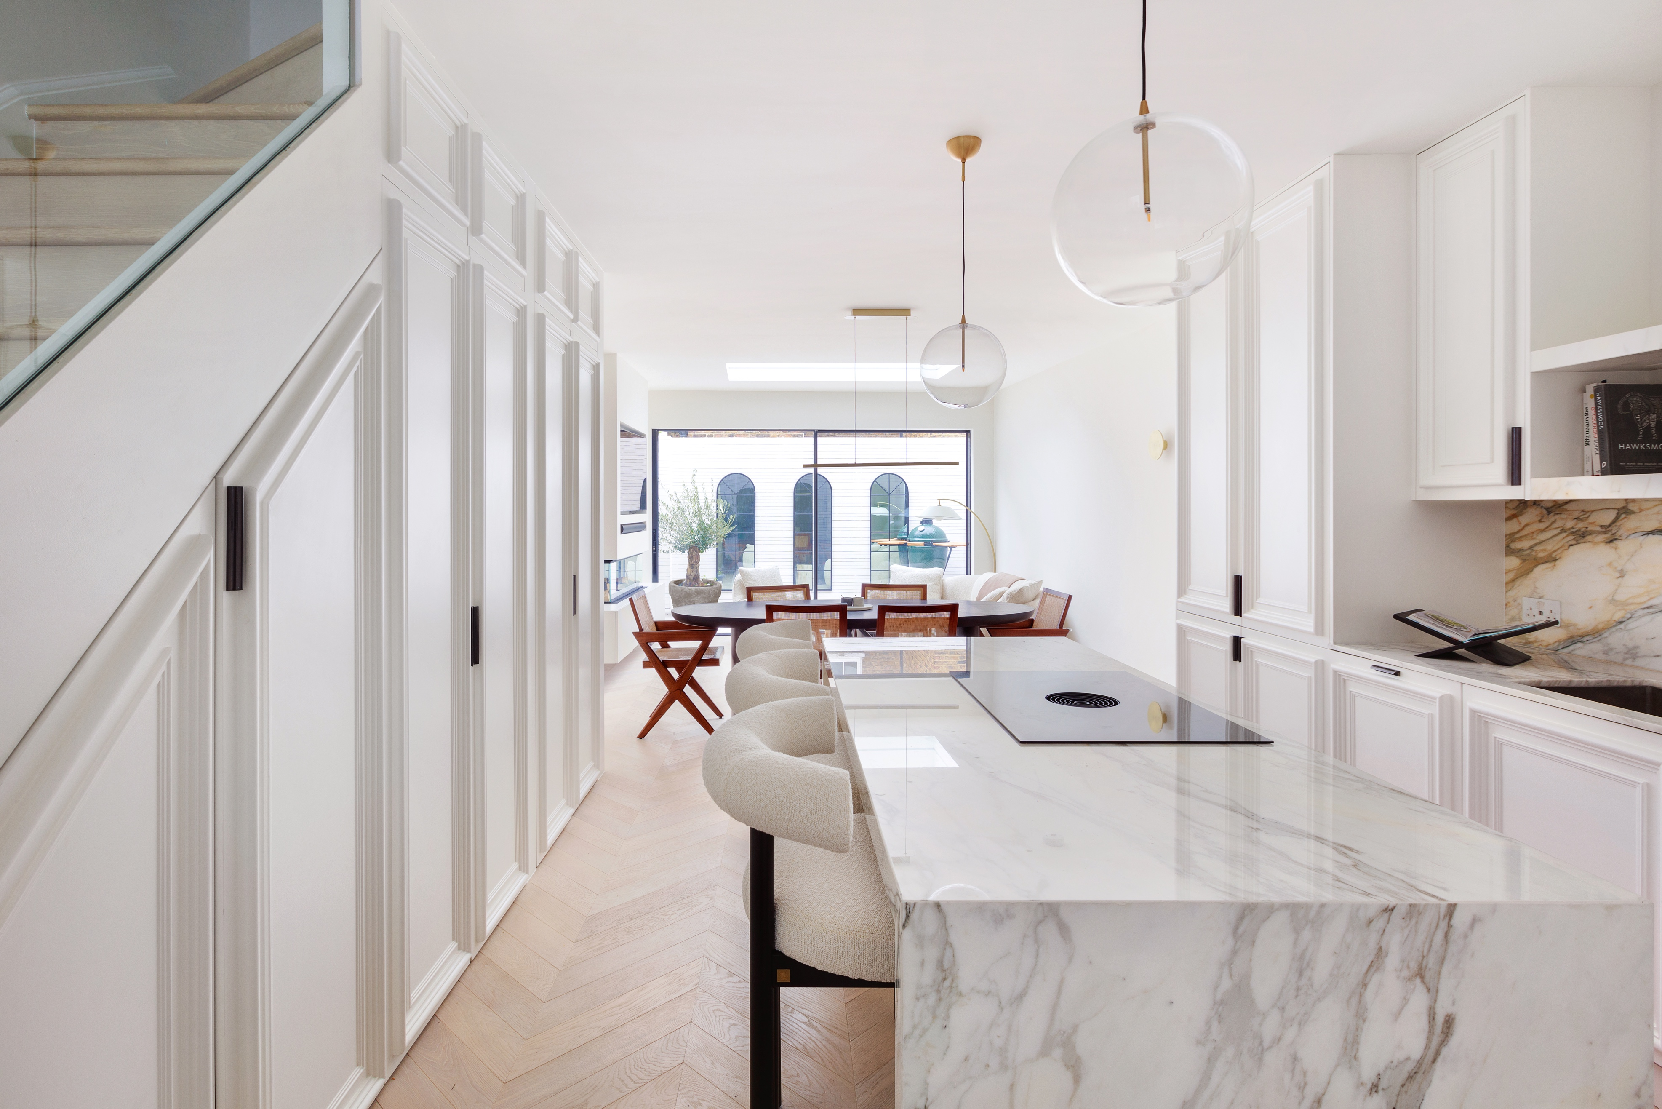
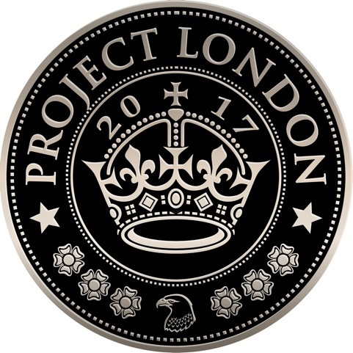

Architecture | Interior Design | Project Management

Senior Architect – Dubai
Project London – Dubai is seeking a Senior Architect to join us in the UAE.
We are an award-winning architecture, interior design, and project management studio specialising in high-end residential projects. Having established a strong reputation in London, we are now expanding into Dubai to replicate our successful model in a new and fast-growing market.
This is a rare opportunity to play a pivotal role in launching our Dubai business, working closely with the director to establish our presence, grow our portfolio, and build a first-class team.

About You
You are a highly motivated and entrepreneurial architect with a proven track record in high-end residential design. You are passionate about architecture and interiors, confident in leading projects from concept through delivery, and excited by the opportunity to help establish a new studio in one of the most dynamic cities in the world.
You will thrive on responsibility, combining design flair with commercial awareness, and you will bring the energy and adaptability required to help build a business from the ground up.

Key Responsibilities
- Lead projects from concept through to completion, delivering exceptional quality at every stage.
- Prepare and present client documentation and design packages tailored to the luxury market.
- Manage project timelines, budgets, and profitability, ensuring financial targets are met.
- Support the director in developing a pipeline of new work, from pitching to project onboarding.
- Build and maintain strong client relationships, acting as a trusted advisor throughout the design and delivery process.
- Communicate clearly with clients, consultants, suppliers, and contractors.
- Mentor and support future team members as the Dubai studio grows.
- Contribute to shaping and implementing systems, processes, and standards for the new office.
- Represent Project London professionally within the UAE design and property community.

Required Qualifications and Skills
- A degree in architecture.
- At least five years of post- part 3 (or equivalent) degree industry experience, ideally within high-end residential projects.
- Strong experience in concept design, technical delivery, and on-site project management.
- Proficiency in Vectorworks (2D), Adobe InDesign, and Microsoft Office.
- Excellent design, organisational, and communication skills.
- Fluent in written and spoken English, with strong presentation skills.
- Knowledge of UAE building regulations and construction standards.
- Commercial awareness and an understanding of project profitability.
- Entrepreneurial mindset, adaptable and motivated by the challenge of building a new venture.

Why Join Us?
- Be part of the founding team for Project London – Dubai, with direct impact on shaping the business.
- Competitive salary based on experience.
- Opportunity for career progression as the studio grows, including leadership potential.
- Opportunity to work closely with the London office.
- Join a dynamic, collaborative, and ambitious group with a proven track record in London.

How to Apply
Please send your CV, portfolio PDF, salary expectations, and availability to start to info@projectlondon.co.uk.

Additional Information
- Applications are open to candidates already based in the UAE.
- You must hold the necessary documents entitling you to live and work in the UAE.
- We regret that we can only respond to successful candidates.
- No recruitment agency applications please.

